

Name : Khoo Hong Yi

Login ID : khoohongyi@oasis-portal.com

Course title : Executive Diploma in Culinary Arts & Hospitality Management

Subject Code : CA03 International Cuisine

Submitted date: **07/09/ 2017**

**Table of Contents**

|  |  |  |
| --- | --- | --- |
| **No** | **Details** | **Page** |
| 1 | Executive Summary | 2 |
| 2 | Introduction | 3-8 |
| 3 | Assignment Question |  |
|  | Part 1 | 9-18 |
|  | Part 2 | - |
|  | Part 3 | - |
|  | Part 4 | - |
| 4 | Conclusion | 19 |
| 5 | References | 20 |
|  | Appendix | - |

**Executive Summary**

In this assignment, we will learn about the purpose of this unit that is to be able to understand International cuisine tithing culinary art and hospitality management.

We will need to choose one dish from each cuisine. The cuisines are Chinese, western and Indian cuisine. From each cuisine, we will need to recreate or alter the original recipe into our own recipe.

From this assignment, I learn that the difference for both Chinese and Indian cooking style is that, Chinese food is very high heat, steamed, pickled, simmer and other stir fry. And for Indian, Indian food is made with "Daam" or cooked in a sealed pot, or "Tandoor" or a local oven cooked in a Paranth or flat boiler, rather than using a simple cooking method.

Chinese noodles eat wheat, and bread in India is mainly flat bread or tortillas. Rice is used in these two countries as pure steamed rice, but flavored rice flavors are different. China's rice seasoning is a rice-based sauces, while the Indian rice seasoning is carried out during the cooking process, so the aroma is in the rice itself.

Oil is also different, Chinese people use most of the white oil, such as peanut oil, sunflower oil, as well as animal fats, such as lard. Sesame oil for seasoning. Indian cooking uses mustard oil, coconut oil, some white oil and plenty of butter or clarified butter.

Chinese cooking do not use curd, and India uses a lot. Chinese food uses a lot of meat and poultry, fish and seafood and smaller animals. Indian cooking is limited to less animal protein sources.

Indian food also uses a lot of milk products other than Ghee and Curd. Paneer or Cottage Cheese is not used for Chinese food. Both of these foods have a wide range of regional, cooking style has been developed for thousands of years.

Western food or Western cuisine is the cuisines of Europe and the other Western country. Sometimes when someone said "western food", we'll think about burger, steak, fries, ribs, etc. And now, how about the food characteristics? For Asian, the Western food have a jumbo size, but for them it's only a regular size. The Asian can feel very full with the western size serving, but not for them. And about the food? Meat is so important in western food (example: steak). It is like the main star, not like the Asian cuisine. In the Asian cuisine meat is only a small part in the food, their main food is more like rice or noodle. The Western also more using the corn, fries, steamed veggies, and mashed potatoes than the rice. And about the seasoning, the Western using ketchup, tomato sauce, mustard, gravy, sauce of tartar, and the other sauces.

**Introduction**

International cuisine is the food from all over the world. Cooking is a culinary practice and a traditional characteristic style, often associated with a particular area, country or culture. To become a global food, local, regional or national cuisine must be spread all over the world and its food is spread all over the world. Food preservation, storage, transportation and production have made significant progress in the last century, and today many countries, cities and regions have traditional cuisine and many other global delicacies.

For Malaysian international cuisine are as below by country.

**Korea**

* 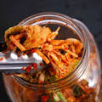kimchi
* Patbingsu

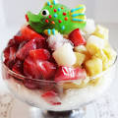

* 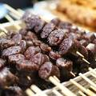Sundae
* Jorim

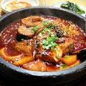

* Ssam

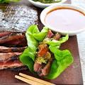

* 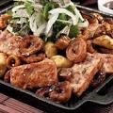Gopchang

**Thailand**

* Namtok

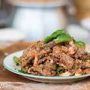

* 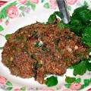koi
* yam khai dao

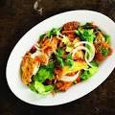

* Mu kratha

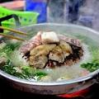

* 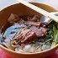Kuai-tiao phat khi mao

**FILIPINO**

* 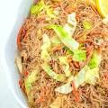pancit
* 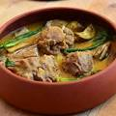Kare kare
* 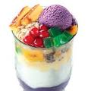Halo-halo
* 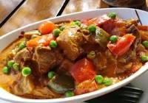Kaldereta

**Japanese**

* 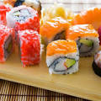Sushi
* 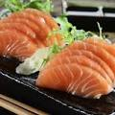Sashimi
* 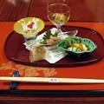Kaiseki
* 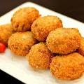Korokke
* Karaage

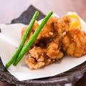

**Assignment Questions**

**Assignment 3**

You should create your own dish from each international cuisine listed.

Required:

Choose one dish for each cuisine:

(i) Chinese cuisine (ii) Indian Cuisine (iii) Western Cuisine

You should be able create own recipes.

1. Chinese cuisine

Original recipe: **Chinese Chicken – Sweet and Sour**

**Serves 4-6**

* 1 lb lean chicken meat, cubed
* 5 tbsp vegetable or peanut oil
* ½ tsp minced garlic
* ½ tsp finely chopped fresh ginger root
* 1 green bell pepper, coarsely chopped
* 1 onion, coarsely chopped
* 1 carrot, finely sliced
* 1 tsp sesame oil
* 1 tbsp finely chopped scallions

**Marinade:**

* 2 tsp light soy sauce
* 1 tsp Shaoxing rice wine
* pinch of white pepper
* ½ tsp salt
* dash of sesame oil

**Sauce:**

* 8 tbsp rice vinegar
* 4 tbsp sugar
* 2 tsp light soy sauce
* 6 tbsp tomato ketchup

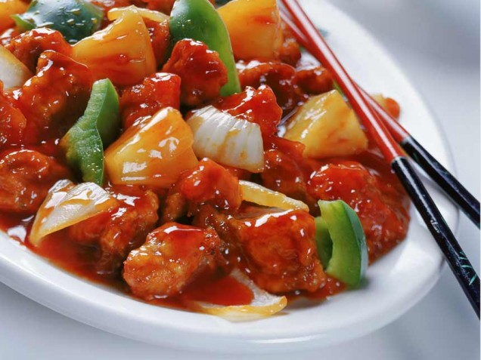

**Directions:**

1. Place all the marinade ingredients in a bowl and stir.
2. Add the chicken pieces and marinate the chicken for at least 20 minutes
3. To prepare the sauce, heat the vinegar in a pan and add the sugar, light soy sauce and tomato ketchup.
4. Stir to dissolve the sugar and then set aside.
5. In a preheated wok, heat 3 tbsp of the oil and stir-fry the chicken until it starts to turn golden brown.
6. Remove and set aside.
7. In the clean wok, heat the remaining oil and cook the garlic and ginger root until fragrant.
8. Add the vegetables and cook for 2 minutes.
9. Add the chicken and cook for 1 minute.
10. Finally, add the sauce and sesame oil, then stir in the scallions and serve.

Own recipe: **Chinese Chicken – Sweet and Sour**

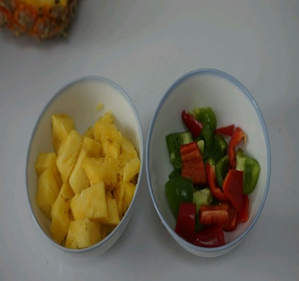

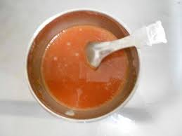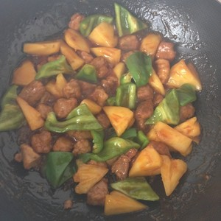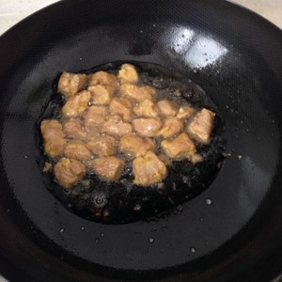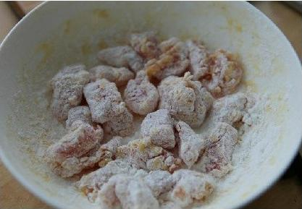

**ingredient**

1. Pork ridge 4
2. Pineapple half
3. Green pepper 1
4. Starch amount
5. 1 egg
6. Twilts tomato sauce 5 tablespoons
7. 2 tablespoons of sugar
8. Take 1 teaspoon of soy sauce
9. Balsamic vinegar 1 tsp
10. The amount of wine
11. Salt amount
12. Edible oil

1. 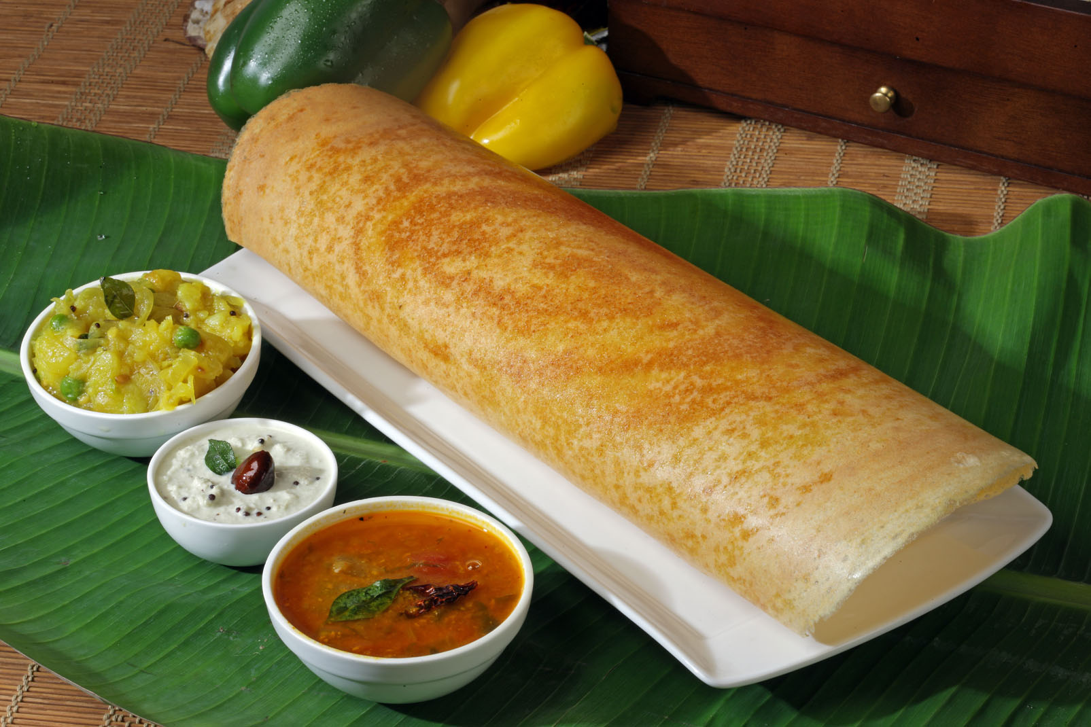Indian Cuisine

Original recipe: **Masala Dosa (South Indian Crepes)**

**Yield: 4-6 servings**

**Ingredients**

* + - 1-1/2 cups long grain rice
    - 1/2 cup urad dal (polished black lentil or white lentil)
    - 3 quarts water
    - Salt
    - 1 medium onion, chopped
    - 1 – 2 green chilies, chopped
    - 1 Tbs. ghee (clarified butter) or regular butter
    - 1/2 tsp. black mustard seeds
    - 1/2 tsp. chana dal (split black chickpeas)
    - 1 sprig curry leaves
    - 1/2 tsp. turmeric powder
    - 2 large potatoes, boiled
    - 8 oz. coconut, cilantro and tomato chutney (optional)
    - 16 oz. sambar (vegetable lentil stew, optional)

**Directions**

1. Prepare Dosa Batter:Soak rice and urad dal in separate bowls for 4-6 hours. Strain.
2. Process rice and urad dal mixture in commercial grinder or food processor. While grinding, add water a cup at a time until it reaches the consistency of pancake batter.
3. Salt to taste.
4. Cover mixture and let sit overnight. Do not refrigerate; it needs to ferment.
5. Prepare Masala Dosa Filling: Add oil or ghee to a skillet.
6. Add mustard seeds and chana dal.
7. Shake mixture over the flame until golden brown.
8. Add curry leaves (whole leaf), green chiles, and onions.
9. Sprinkle turmeric powder and salt (for taste). Stir.
10. Break up boiled potato into small chunks and add them to your mixture. Add water and stir.
11. Prepare Masala Dosa: Pour refrigerated dosa mixture into a small bowl with a flat bottom.
12. Pour batter into a greased skillet.
13. Immediately, starting from the center, begin forming a circular shape with the batter using the flat-bottomed dish.
14. Brush on ghee (or regular butter) to frying dosa.
15. Place filling near the center of the dosa.
16. Lightly lift the edges of the dosa.
17. Begin rolling from the edge of the dosa as you would a wrap.
18. Remove dosa from hot top or skillet.
19. Masala Dosa is typically served with coconut, cilantro and tomato chutney as well as sambar (vegetable lentil stew)

Own recipe: **Masala Dosa (South Indian Crepes)**

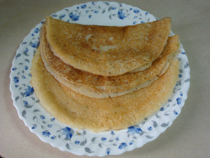

Ingredients

Rawa – 1 and 1/2 cups

Plain flour– 1 cup

Yoghurt/Curd – 3/4 cup

Salt to taste

Baking soda – 1 pinch

Black pepper corns 1/2 tsp crushed well.

Cumin – 1/4 tsp

Water – 1-2 cups

1. Western Cuisine

Original recipe: **Spaghetti Carbonara**

Serves: 4

Ingredient

* 360g spaghetti
* 200g guanciale (pancetta) or bacon
* 2 whole eggs and 1 yolk
* 80g grated Parmigiano or Pecorino (ewe's cheese)
* olive oil
* salt
* pepper

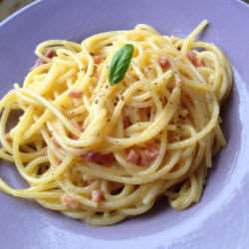

**Method**

1. Bring a large pan of water to the boil (you will need at least 4 litres for this amount of pasta - if you're doing it for more than 4 servings add an extra litre every 100g pasta), adding two not too full dessertspoons of coarse salt when water starts to boil.
2. Throw in the pasta about a minute after the salt.
3. Do NOT break the spaghetti! Even if they don't fit in the pan, the best way is to hold them in a bunch vertically and immerse. Let go and they will fan out in all directions, and as they soften will sink and cook just perfect.
4. When the pasta is nearly ready (see packet of pasta for cooking time) shallow fry in a non stick pan the diced pancetta for only a couple minutes, it doesn't need more.
5. Drain the pasta and throw it in the pan together with the pancetta and continue to fry it, adding a little glug of olive oil. (The pasta needs to be just short of "al dente" when you drain it as it will continue cooking in the pan.)
6. Off the heat prepare a large serving bowl and lightly whisk two full eggs and one yolk with a pinch of salt and the grated cheese.
7. Throw the pasta sauteed with the pancetta on top of it and give it a quick mix before serving.
8. Season to taste with freshly ground black pepper.

Own recipe: **Spaghetti Carbonara**

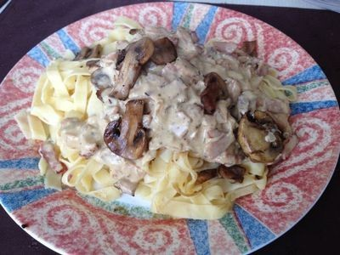

**Ingredient**

* 2 tbs olive oil
* 1 onions sliced
* 1 garlic clove crushed
* 4 bacon strip
* 250 g mushrooms
* 1/2 cup white wine
* 300 mls cream
* 1 egg beaten

**Conclusion**

For my conclusion, learning about international cuisine makes me know more about the different dishes around the world. The food prepared for the dishes determines its characteristics. This is because the ingredients used, the handling of these ingredients, the cooking style used, the preferred flavor, the culinary technique, and the cooking utensils and fuels for cooking are sometimes influenced by the cooking style.

The factors of the dishes both in the past and in the past, is formed by a number of basic factors that are unique to a group of people who form a particular food culture. These factors determine the use of essential ingredients, cooking methods, cooking media, cooking speed, food mix and so on.

**Some of these factors have been listed below:**

Climate: Since ancient times, the climate has been the most influential factor. The climate determines several aspects of cooking, including the use of ingredients and cooking style. For example, shaving ice is a hot dessert in the world's hot and humid parts, and hot soup is more popular in the world's colder areas.

Economic status: This is the second most important factor in determining the cooking style of different dishes. The world's underdeveloped areas, poor economic conditions, the use of very simple cooking techniques, the least ingredients, and put a lot of pressure on food preservation, and the world's developed areas to carefully crafted the technology and the use of several fine ingredients known. A typical example is the difference between the Sudanese cooking style and the French cuisine.

The level of modernization: This determines the cooking speed and the type of cooking techniques used by different dishes. For example, in remote Afghan villages, people still believe in cooking wood on wood burning stoves, and microwave cooking will be unheard of.

For other countries outside Malaysia, the best dishes as international cuisine is Nasi Lemak, Penang Laksa, Prawn noodle, Nasi Ayam, Roti Canai and for fruits is Durian and Mangosteen.

**References**

Unknown Author, September 10 2015. Online source, [RECIPE] Chinese Chicken – Sweet and Sour. <http://www.thechinesequest.com/2015/09/recipe-chinese-chicken-sweet-and-sour/>

Unknown author,Unkown date,online, source, Masala Dosa (South Indian Crepes) http://www.pbs.org/food/recipes/masala-dosa-south-indian-crepes/

By MammaSERE, unknown date,online source, Original Italian Carbonara http://allrecipes.co.uk/recipe/7490/original-italian-carbonara.a

By Rekha Singh, Jan 1, 2016,international cuisine https://www.slideshare.net/rekhasingh58/international-cuisine-56587802?qid=3bbbeeb0-0de3-45b8-8642-840a51a92036&v=&b=&from_search=2

By rjbenetua, Sep 30, 2009,international cuisine https://www.slideshare.net/rjbenetua/international-cuisine?qid=3bbbeeb0-0de3-45b8-8642-840a51a92036&v=&b=&from_search=3